# Lab [1]: [Introduction]

# 

# Lab [1]: Introduction

**Objective(s)**

1. To learn how to use Command Line/Terminal to run Java programs
2. To learn how to use Java IDE (NetBeans) as a developing environment for Java
3. To be familiar with Java Program’s Structure.
4. To learn Java I/O Statements.

**Tool(s)/Software**

Notepad, NetBeans & Command Prompt

**Description**

***Java Program’s Structure looks like the following:***

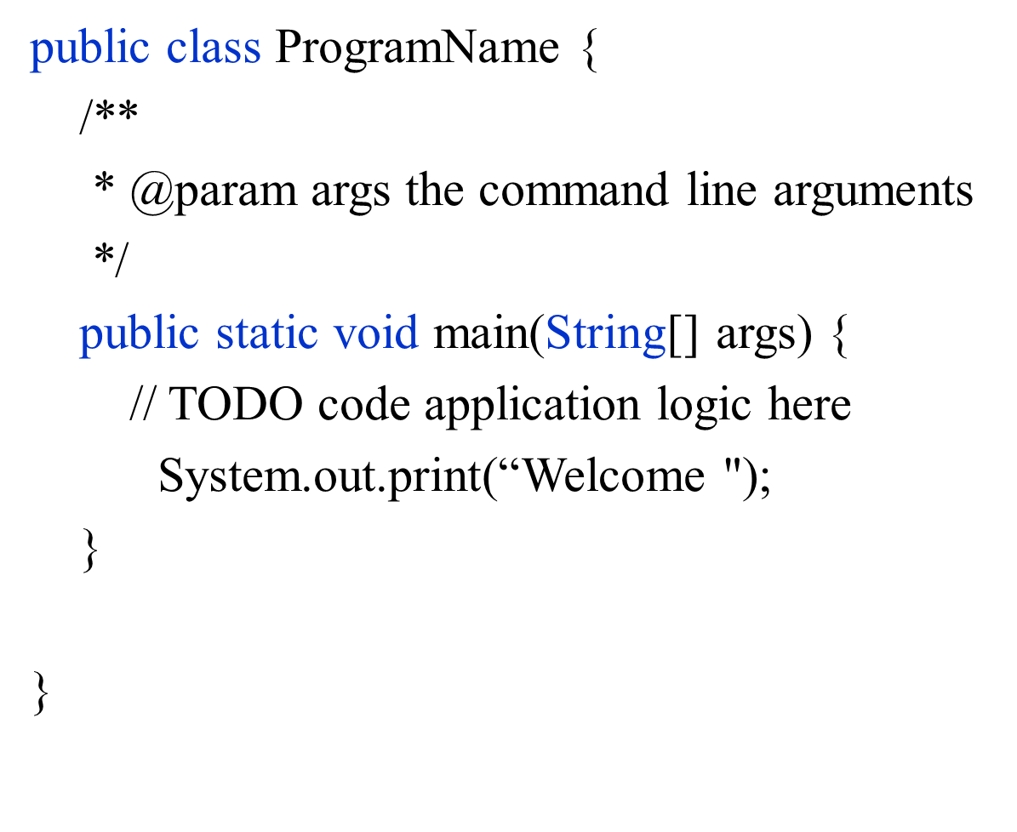

***To use command Line/Terminal to run Java programs:***

1. Start the notepad and write your 1st program.
2. Save this file with the extension AppName**.java**
3. Open the command line/terminal:
   1. Go to the location where you saved your java file. For example, filename is *HelloWorld.java*
   2. 1st : Compile your application: (produce class files)  
      **javac** *HelloWorld.java*

A screen shot of a social media post

Description generated with very high confidence

Screen of a cell phone

Description generated with high confidence

* 1. 2nd : Run your application:  
     **java** *HelloWorld*

A screenshot of a cell phone

Description generated with high confidence

***How to use JAVA IDE (NetBeans) for Java Programming***

1. Open NetBeans IDE

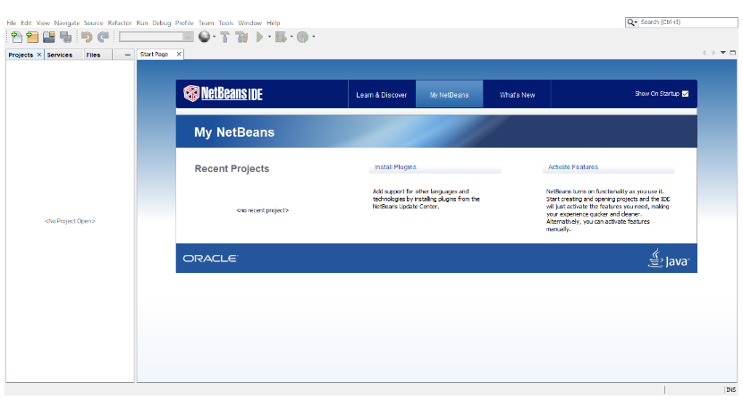

1. Select File and New Project

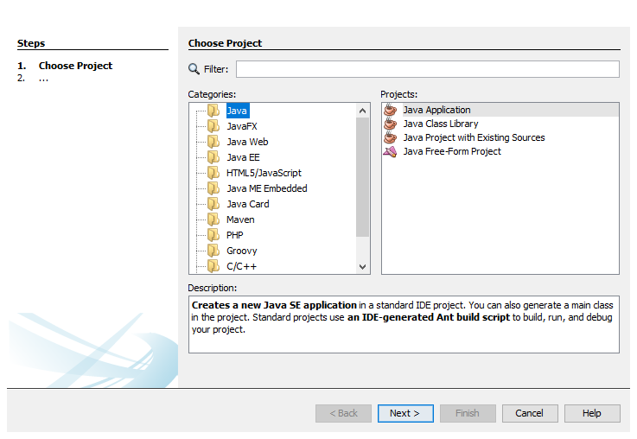

1. Press Next> button and write name of the Java program
2. Press Next > button to finish the dialogue screen

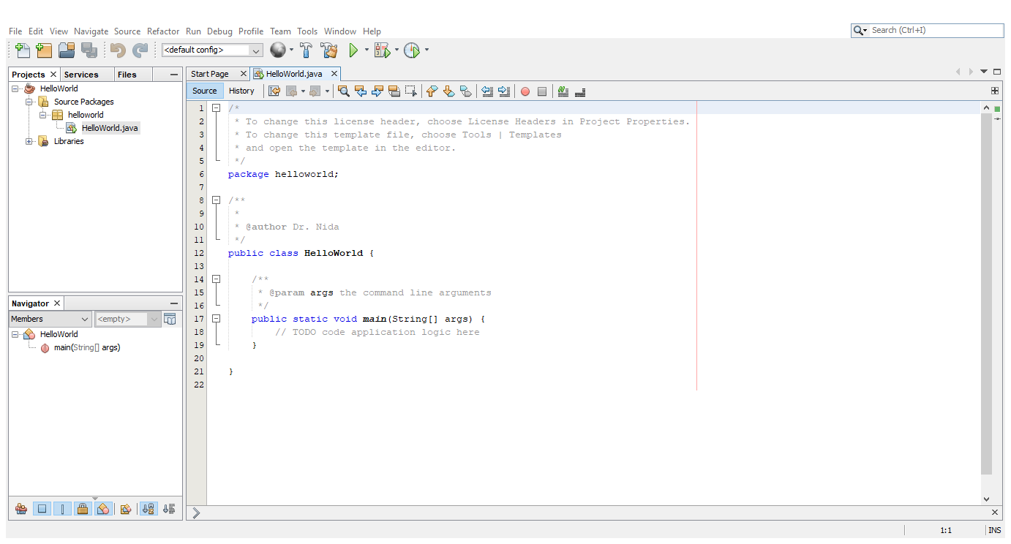

1. Now you are ready to write your code after the main()
2. Write your code and Compile/Run the Program to get output.

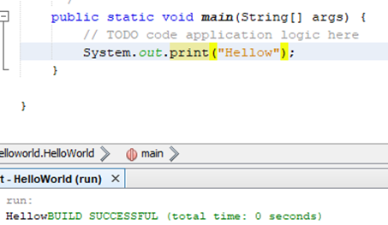

***Java I/O Statements***

1. Output Statements:
   * System.out.print(“ ”)
2. Input Statements:
   * import java.util.Scanner;
   * Scanner input = new Scanner(System.in);
   * ….. Var=input.nextInt();
   * ….. Var=input.next();
   * ….. Var=input.nextByte();
   * …..

**Tasks/Assignments(s)**

You can solve the tasks either using Command Line or IDE (NetBeans)

**Task 1:**

Write a Java program that takes the birth year from the user and prints her/his age. Here are sample runs of the program:

***Sample 1:***

Enter your birth year: 1994

Your Age is: 24 years

***Sample 2:***

Enter your birth year: 2000

Your Age is: 18 years

**Hints**: How to solve it:

* + Draw the solution’s flowchart.
  + Transform that flowchart into a program.
  + Run it using the command line/terminal.
  + If any error messages appear, try to understand them and troubleshoot.

**Task 2:**

Write a program that converts a Fahrenheit degree to Celsius using the formula:



***Hints:*** *You will use Input statement to get Fahrenheit as input, convert it to Celsius and then display result.*

**Deliverables(s)**

Codes for the previous tasks to be shown to the lab instructor.

***Resources:***

* + [**Java and the Windows Command Prompt**](http://introcs.cs.princeton.edu/java/15inout/windows-cmd.html)